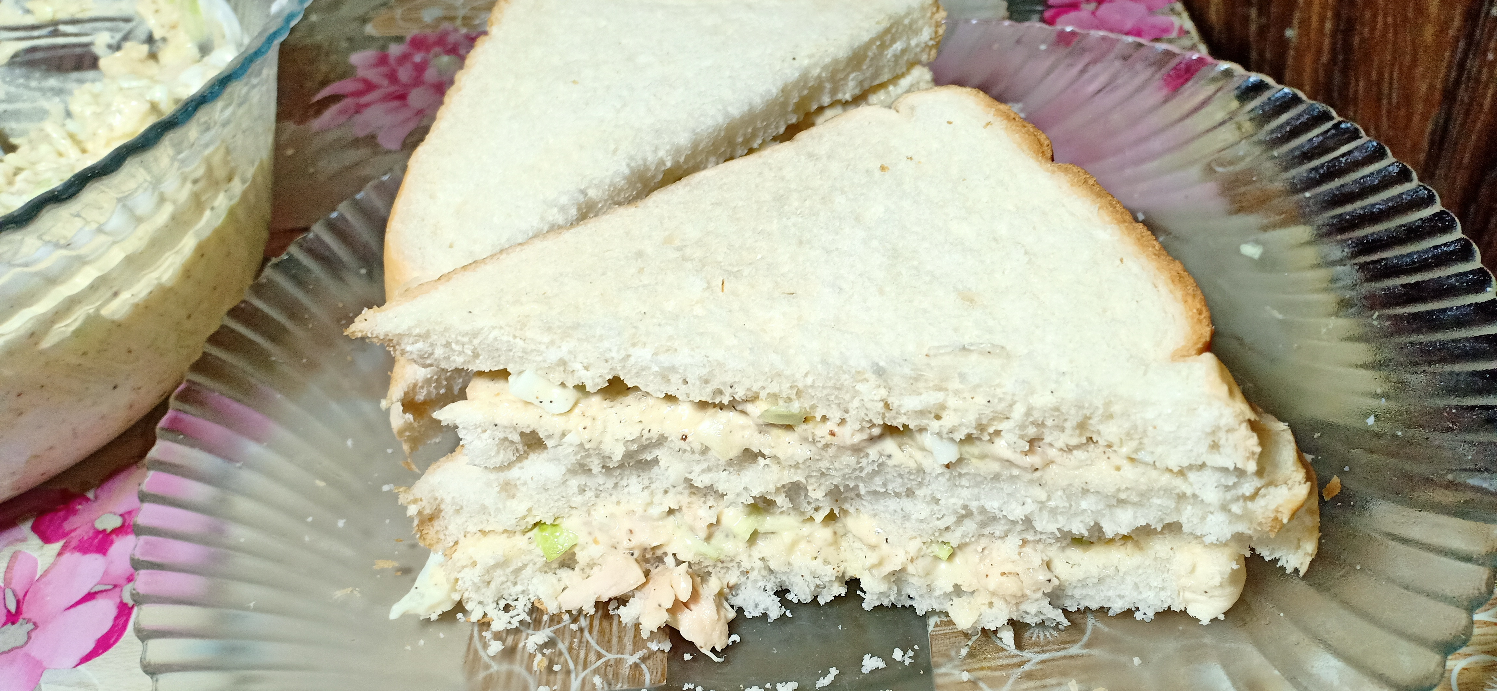

**Ingredients**

* ¼ kg Boiled shredded chicken
* ½ tablespoon salt / namak
* 4 boiled chopped eggs
* 1 cup chopped cabbage / band goobi
* 1 tablespoon black pepper / kaali mirch
* 1 cup / ¼ kg mayonnaise
* Breads as per requirement

**Recipe**

* Mayonnaise ma cabbage , egg , chicken , salt and black pepper daal kr mix kr lyn .
* Ab us mixture ko bread p lga k paish kryn